**Project Report**



**Since 1962**

**Volunteering at Human Team Foundation**

Submitted by

**Yash Sarang - 47**

of

**Group No: 7**

Submitted to

**Dr. Geeta Ajit**

(in partial fulfillment of the requirements of the PCE-2 course 2022-2023)

Vivekanand Education Society’s Institute of Technology

Chembur, Mumbai – 400 074

October 2022

**Declaration**

I, **Yash Sarang**, student of **Semester V**, third year Engineering from **Department of Artificial Intelligence and Data Science**, V. E. S. Institute of Technology, hereby declare that the project entitled **Volunteering at Human Team Foundation NGO**, submitted to the University of Mumbai for the academic year 2022-2023, is a record of an original work done by me under the **guidance of Dr. Geeta Ajit**, Assistant Professor, Department of Humanities and Applied Sciences, V.E.S. Institute of Technology, Mumbai -400074.

This project report is submitted as a partial fulfillment of the requirement of the subject **Professional Communication and Ethics -2** in Semester V.

**Date:** 17/10/22 **Name:** Yash Sarang.

**Place**: Chembur **Signature:**

**CERTIFICATE**

This is to certify that the report entitled: **Volunteering at Human Team Foundation NGO**

that is being submitted by : **Yash Sarang.**

from (D11AD AI & DS, V.E.S Institute of Technology)

In partial fulfillment for the subject Business Communication and Ethics -2 to the University of Mumbai is a record of bonafide work carried out by him under my guidance and supervision.

Dr. Geeta Ajit

Assistant Professor

Department of Humanities and Applied Sciences

V.E.S. Institute of Technology

Mumbai -74.

**Group No: 7**

| **Sr No.** | **Group Members** | **Roll No** | **Designation** |
| --- | --- | --- | --- |
| 1 | Arunim Chakraborty | 7 | Member |
| 2 | Shubham Hadawle | 17 | Member |
| 3 | Janhavi Khanvilkar | 27 | Member |
| 4 | Manav Pahilwani | 37 | Deputy Leader |
| 5 | Yash Sarang | 47 | Leader |
| 6 | Avanish Srivastava | 57 | Member |
| 7 | Heramb Pawar | 67 | Member |

**Acknowledgements**

I am very grateful to our honored professor, Dr. Geeta Ajit, for her invaluable guidance, supervision and encouragement throughout the work. Without her kind patronage and guidance, our project would not have taken shape.

We owe sincere thanks to all the mentors at Human Team Foundation and Adharwad Old Age Home for their advice and counseling from time to time.

**Table of Contents**

1. **Abstract** 7
2. **Chapter 1: Introduction**  8-9

1.1 Overview 8

1.2 Background and Motivation 8

1.3 Objective 9

1.4 Methodology 9

1. **Chapter 2: Description**  10-19 2.1 Human Team Foundation 10

2.2 Aadharvad Old Age Home 11

2.3 Issues Faced 12

2.4 Our Solutions 13

2.5 Activities Done 14

2.7 Beach Cleaning Drive 15

2.6 Photos and Description 16-19

1. **Chapter 3: Analysis**  20
2. **Conclusion**  21
3. **References and Bibliography**  22
4. **Appendix** 23
5. **PPT of Presentation**  24-33
6. **Project Proposal**  34-36

**Abstract**

The main motto of assigning us this project was to develop ourselves, and allow us to experience the difficulties faced by the people living out there,and also contribute 15 days (or 30+ hours) to an organization and society in all possible ways. We learned about the requirements and the struggles of living in the real world i.e out of our comfort zone. Those 15 days completely changed our perspective of living our lives.

**Chapter 1: Introduction**

**1.1 Overview**

India has the second highest population of elderly people in the world with 104 million people above the age of 60 years. Increasing life expectancy and a reduction in fertility rate are the chief causes of this. Between 2001 and 2011, India’s population grew by 17.7%, while the elderly population shot up by 35.5%. This led to a sharp increase in the old-age dependency ratio – more elders per 100 persons in the age group of 15-59 (working age). Life expectancy of women in India, as observed in the entire world, is higher than men, as is their proportion. According to records from 2009-2013, life expectancy at birth for women was 69.3 years and for men 65.8 years.

**1.2 Background and motivation**

Facts about reality of Old Age People in our Society

* 90% of the elderly have no official social security - no gratuity, no provident fund, no pension.
* 57% of the oldest old are widows or widowers - proportion of widowers higher than widows.
* Out of 82% of economically dependent elders, 72% suffer physical abuse, and resulting health problems.
* Around 52% of the elder population is living in poverty and in very poor health conditions.

While doing our research we came across these facts which were very disturbing and this forced us to work for their benefit

**1.3 Objective**

We as a team wanted to grow an emotional bond with the people, know about their struggles. Help them with their pending work. We believe our interaction and help would bring a smile on their face and create a memory which lives with them forever.

**1.4 Methodology**

We contacted many NGOs working towards the betterment of society, we found out a NGO named Human Team Foundation that fits our goals.We expressed interest in working as volunteers at the NGO. They accepted our proposal and we started working with them.The NGO had

Our work with the NGO can be divided into 3 parts :-

1. Interacting and helping the people in Adharwad Old Age Home with their daily chores.
2. Helping the NGO with their database and the website
3. Taking the people to the Bank and completing their pending work in the Bank.

The people at the Old Age home were a bit hesitant in the beginning when talking to us as we were some unknown people to them as volunteers but as time passed they started expressing themselves and were very friendly.

We celebrated the birthday of Ms. Nilima and the smiles on their faces were heart-touching. We sat with them while they had their meals, read newspapers, tried to complete the SUDOKU in the newspaper with them, and went on a walk with them as they continued their stories. To sum it up we tried to create an emotional bond with them.

**Chapter 2: Description**

**2.1 Human Team Foundation**

Human Team Foundation is a Non Governmental Organization is located in Chembur, Mumbai Maharashtra.Its registration ID is 'MH/2018/0206584' . The NGO registration is done by Sub-Registrar with registration number 580 on the date of 02-04-2018. The NGO provides helps majorly in areas like:

* Agriculture,
* Animal Husbandry,
* Dairying & Fisheries,
* Children,
* Civic Issues,
* Differently Abled,
* Disaster Management,
* Education & Literacy,
* Aged/Elderly,
* Environment & Forests,
* Food Processing,Health & Family Welfare,
* Housing,Human Rights,Labor & Employment,
* Land Resources,
* Rural Development & Poverty Alleviation,

**Human Team Foundation Team:**

* Niraj Arvind Mishra (President),
* Sushil Ramhinch Tiwari (Secretary),
* Riddhik Hasmukh Pankhania (Treasurer)

**Joining And Assignment Of Work:**

We approached the Ngo and after some paperwork we joined in as volunteers on 23rd July, 2022.On the first Day of joining we were briefed about the working model of the Ngo and we were assigned “Adharwad Old Age Home” in Koparkhairne, as a place to service at.Aadharwad was directly associated, funded and looked after by The Human Team Foundation.

**2.2 Aadharvad Old Age Home**

Established in the year 2005, Adharwad is a philanthropic trust registered under the name of Adharwad Niradhar & Apang Mahila Utkarsh Trust and now ISO 9001:2015 certified. The Trust mainly runs an old age home for elderly people, both male and female, who are homeless and face health problem

The prime focus of Adharwad is to take good care of elderly people and any unfortunate suffering from Alzheimer’s disease or paralysis. The Trust provides good home care and covers all the basic healthcare facilities.

Adharwad is aimed to help the downtrodden, poor and forsaken people whose families have either abandoned them or find it difficult to manage and take proper care of them.

They are also engaged in various welfare programs for the aged, disabled, poor women and the other destitute. They also aim to establish well-equipped hostels to help the community in general, and the weaker sections of the society in particular.

**2.3 Issues faced:**

The issues faced by Old Age People in our society.

1. **Financial insecurity**

While we are living longer, unfortunately, the world of employment and retirement has not evolved at the same pace. Many elderly people are able and more than willing to work past the standard retirement age, but the opportunities are not there. In addition, managing day to day finances and planning for later life can be challenging for older generations as much is now done online or remotely. This can also leave them more vulnerable to fraud and scams.

1. **Difficulty with everyday tasks and mobility**

A person’s mobility and dexterity will naturally decline as they age, which makes completing everyday tasks more difficult. This can gradually cause people to care for themselves and prevent them from being social, pursuing interests, or taking part in activities they enjoy. More support is needed to enable elderly people not only to live independently through products and programs which focus on safety, balance, fitness, and mobility but also to ensure they can continue to thrive as an individual.

1. **Finding the right care provision**

When complete independence is no longer practical, many elderly people require additional care. Sometimes this care can be provided by family members, but this can place a lot of strain on the caregiver in terms of balancing this with work and other family responsibilities. These caregivers need to be given the training, resources, and emotional support necessary to help them deliver the best care for their loved ones and themselves.

1. **Access to healthcare services**

Healthcare can be complicated and disjointed for elderly people, especially for those struggling with long term conditions. The care requires lots of different medical professionals and clinics to coordinate delivery of medication and other types of care.

**2.4 Our Solution**

* **Keep yourself in good health**.

In old age, people should lead a healthy life, taking appropriate measures to maintain good health. They should treat their bodies with love and compassion and with gratitude since it is their life-support and their health and wellbeing depend upon it.

* **Follow medical advice**.

Since health problems multiply in old age, aged people should invariably seek medical advice about their health and stick to it. They should go for regular medical checkups as a preventive measure so that they can proactively safeguard themselves against any health problems which may arise later. They should also take proper medication as prescribed by the doctors and avoid self-medication or experiments.

* **Nurture relationships**.

Old people should avoid being control freaks or troubling others with unreasonable demands, interference in their lives with unwanted advice or petulant behavior. They should respect the boundaries of their relationships and stay within their limits, allowing others to make their own decisions and form their own opinions.

* **Find a purpose**

In old age people lack motivation to keep themselves busy or engage in actions which give them a sense of purpose and direction. They also lack enthusiasm to engage in actions which help them feel good about themselves and overcome feelings of low self-esteem. Studies show that those who have a reason or purpose to be alive and active and expect to see definitive and positive outcomes in their lives have better chances of leading healthier and longer lives

**2.5 Activities Done**

1. **Chatting and Interacting with the people in the Old Age Home.**

Interacting with old people who have felt the hardships and have been abandoned are tough to begin interaction with, they do not open up easily and seeing new faces stresses them a bit.

We took our time and sat with them patiently and started with their names and other basic questions about them, some of them started interacting with us which made it easier for others to chat with us.

1. **Taking them to the Bank.**

We came across their pending pensions, updation of bank passbooks, and some pending signatures, so we decided to take them to the bank by auto rickshaws, and successfully managed to create a new line for them so their work is completed without getting them tired waiting in the line.

1. **Working on their Database.**

All their data was on paper i.e all the donation information, volunteer details, members living in the Old Age Home was not digitized, so we in a meeting with them came to a conclusion that we would be helping them with their database (i.e in excel) and also acknowledged their caretaker about the process of adding the data to the sheet.

1. **Updating and Developing their website.**

We made a few changes to their website.

**5. Beach Cleaning Drive**

JNSSS in association with Municipal Corporation of Greater Mumbai and Divya's foundation, organized Mumbai's Biggest Beach-Cleaning Drive.We, the students of AI & DS Dept, along with other students of VESIT took part in this drive.This was done post the Ganpati Visarjan, on 11th Sept, 2022. The aim was to clean up the beach of the wastes that had been collectedThe immersions of the Idols sometimes also bring wastes. We as responsible citizens of the society, must be careful and more aware of the consequences of our actions, and we must keep our beaches clean.

**2.6 Beach Cleaning :**

Apart from working at NGO. We also participated in a Beach Cleaning Drive organized by NSS in association with MNC of Greater Mumbai and Divya’s foundation, and our Class Teacher (Prof. Ajinkya Valanjoo Sir)

This was held at Dadar Chowpatty on the very next day of Ganesh Visarjan i.e 11th September 2022 under the campaign #SwachhSagarSurakshitSagar initiated by our Hon. PM Narendra Modi**.**



| *Before:* |
| --- |

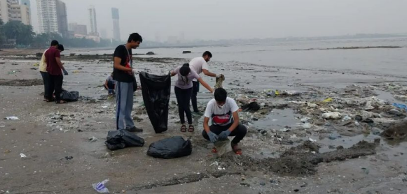

*In Progress….*

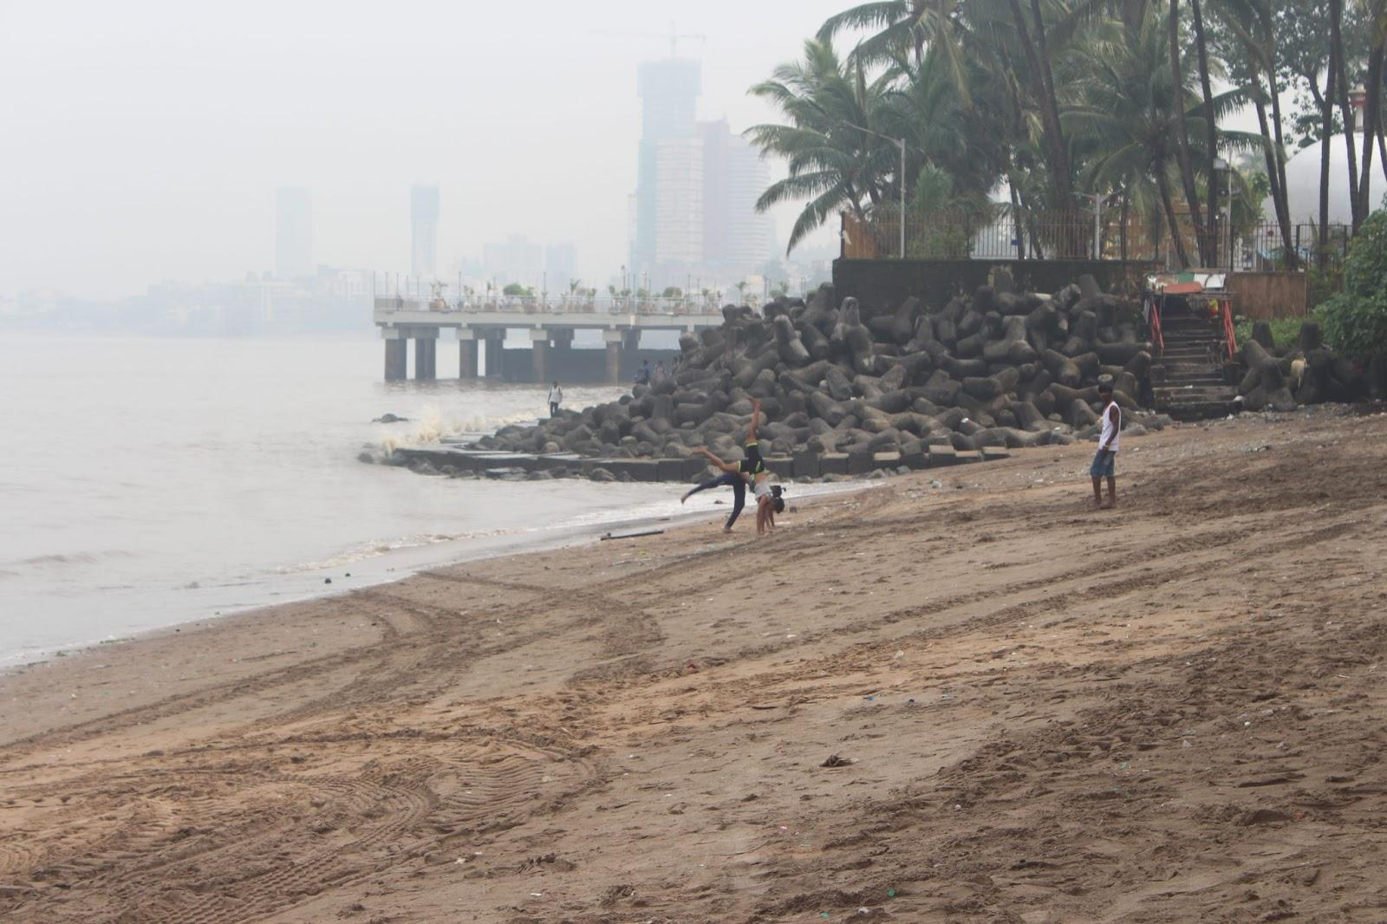

*After:*

**2.7 Photos and Description**

**Adharwad Old Age Home entrance gate:-**

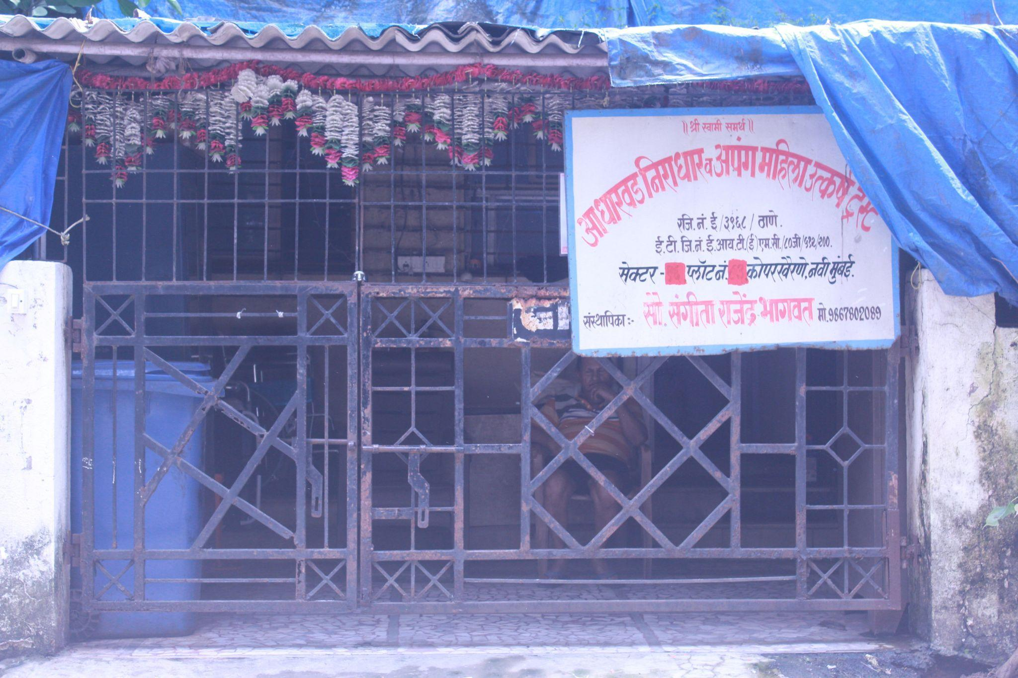

**Meeting and greeting them as we arrive at the Old Age home :-**

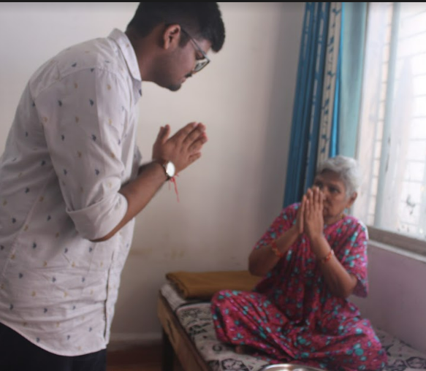

**Celebrating Mrs. Nilima’s Birthday**

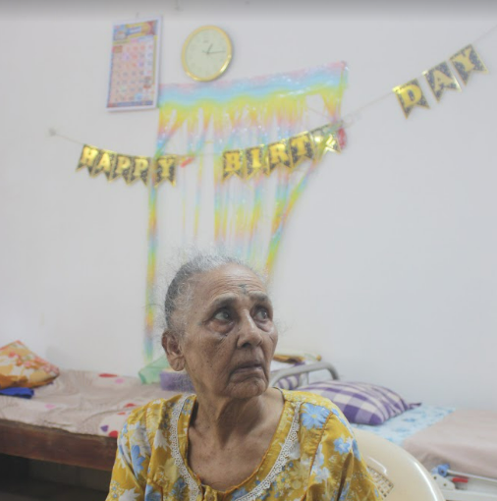

We bought a delightful cake, but she had Diabetes so wasn’t allowed to have it. Also, she was oblivious of the fact that it was her birthday because she had amnesia. As everyone started clapping and singing she was delighted and emotional.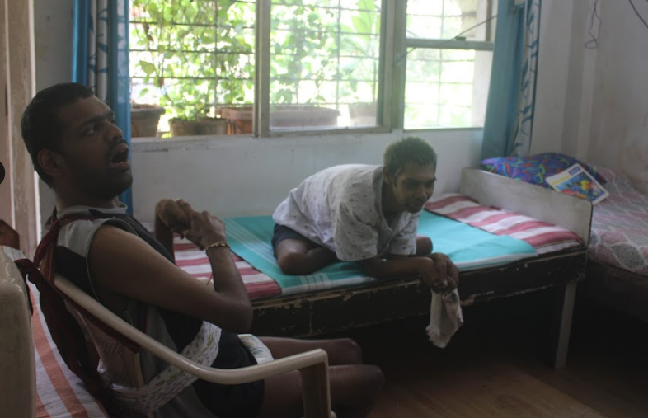

**Arranging Food For NGO and Serving them.**

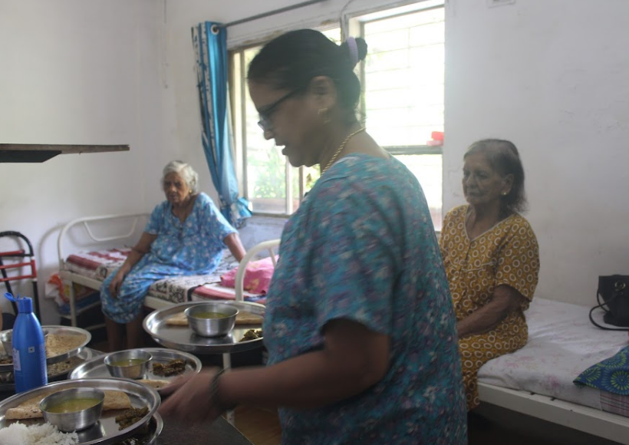

**Donation slip.**

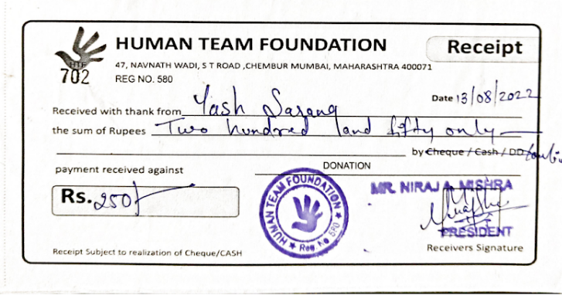

The GP Parsik Sahakari Bank, located in Koparkhairne where we took them for getting their work done also we only had 1st and 3rd saturday or a weekday where we could help them out so divided the task among a Saturday and Monday.

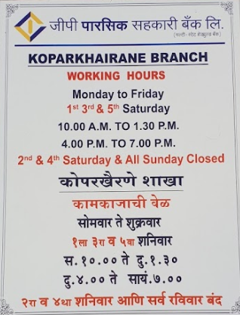

**Chapter 3: Analysis**

We found two categories of people there: the ones who were abandoned and deserted by their families and others who were physically disabled and mentally disturbed. Whatever the case may be, the sufferers were the aged ones. Old age is also called the second childhood, and is a time when one needs love and care of the near and dear ones. Our visit there was an unforgettable lesson. There we learnt more about true life and sharing and caring. There are hundred inmates in the Home. All of them were above the age of seventy five. They all financially dependent on their families or on charity. Their physical condition is good. There are many recreational facilities available to them and these facilities were properly used by them.

However, all of them were lonely and carving for love and affections. We spoke to them, shared our love and we sang songs for them and some of our friends danced for them. They shared their sadness and personal stories with us. However, the care shown to them by the workers at the Home was indeed inspiring.It is important to contribute to social causes from time to time and it helps us in being a better human and understanding others. Also we gain a broader perspective and push our limits considering everything that we see. We got to interact with people and children from different walks of life and considerably increased our communication skills and empathy towards others. We can learn a lot from each individual..Experiences like these make us appreciate the small things that we have or happen in our life. We were pushed out of our comfort zones in terms of traveling or even being ice breakers with them. The visit to the old-age home was a fulfilling experience for me as I came back home with not only memories but also some valuable lessons.

**Conclusions / Recommendation**

To conclude, older age is the toughest time of a humans life. People needs proper support at this stage. That is why we should be concerned about our old peoples. Most importantly, we have to build more old age homes by ensuring improved healthcare services, comfortable lifestyle, recreational facilities and healthy food habit specially for those who don't have anybody at the old stage of life. Moreover, we should never get them to the situation of being alone at the old age. The old people deserve to live good at the old stage of life as they worked really very hard for the society and for us at the young age and ensuring their good and happy life on that stage is our must.

**References and Bibliography**

1. **Human Team Foundation:**

<https://humanteamfoundation.business.site/>

1. **Adharwad Old Age Home:**

<http://www.adharwad.org/>

1. **Youtube:** <https://www.youtube.com/watch?v=UTpUcDG27ks&t=3s&ab_channel=HerambPawar>
2. **News:** <https://origin.mid-day.com/mumbai/mumbai-news/photo/in-photos-mumbaikars-participate-in-beach-clean-up-drive-post-ganpati-visarjan-94030/7>

**Appendix**

Certificate Provided By Human Team Foundation after volunteering for 2 months at NGO**:**

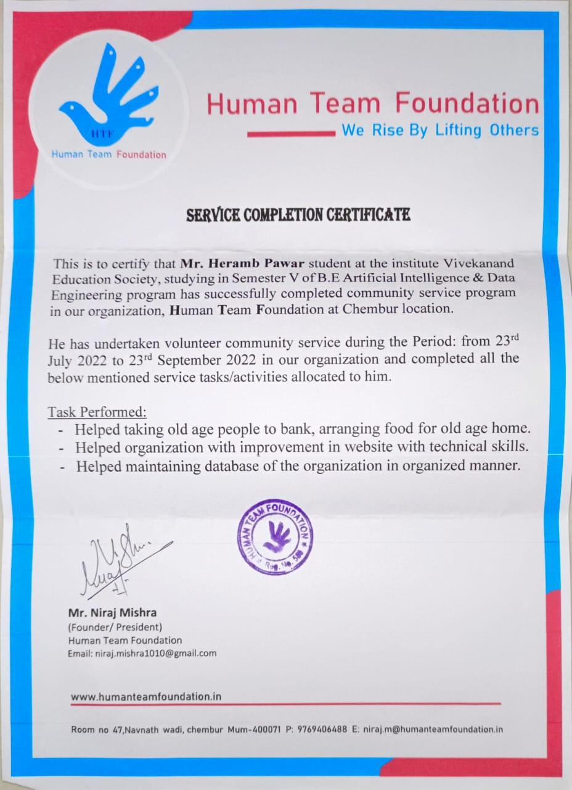

**PPT For Final Presentation**

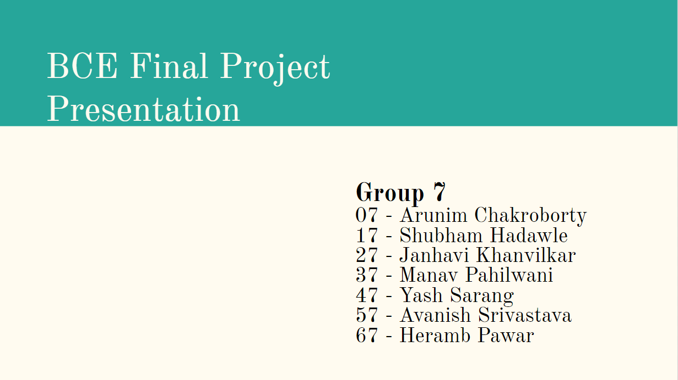

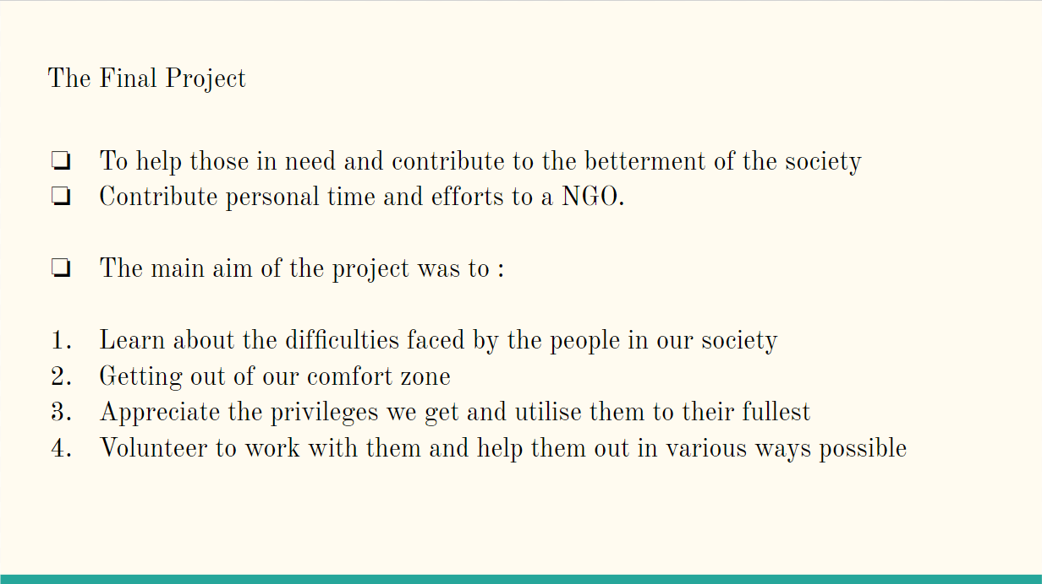

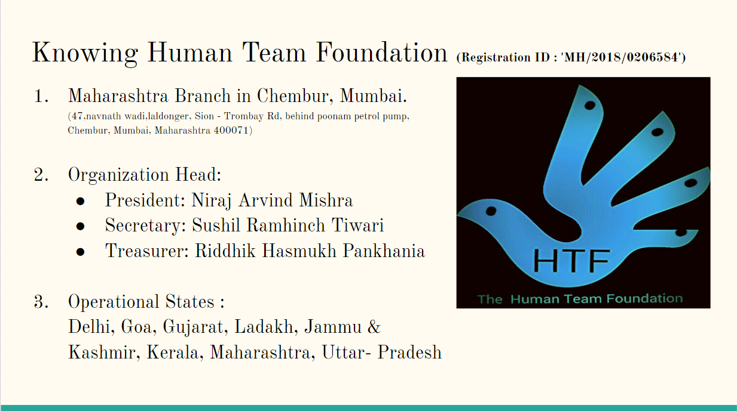

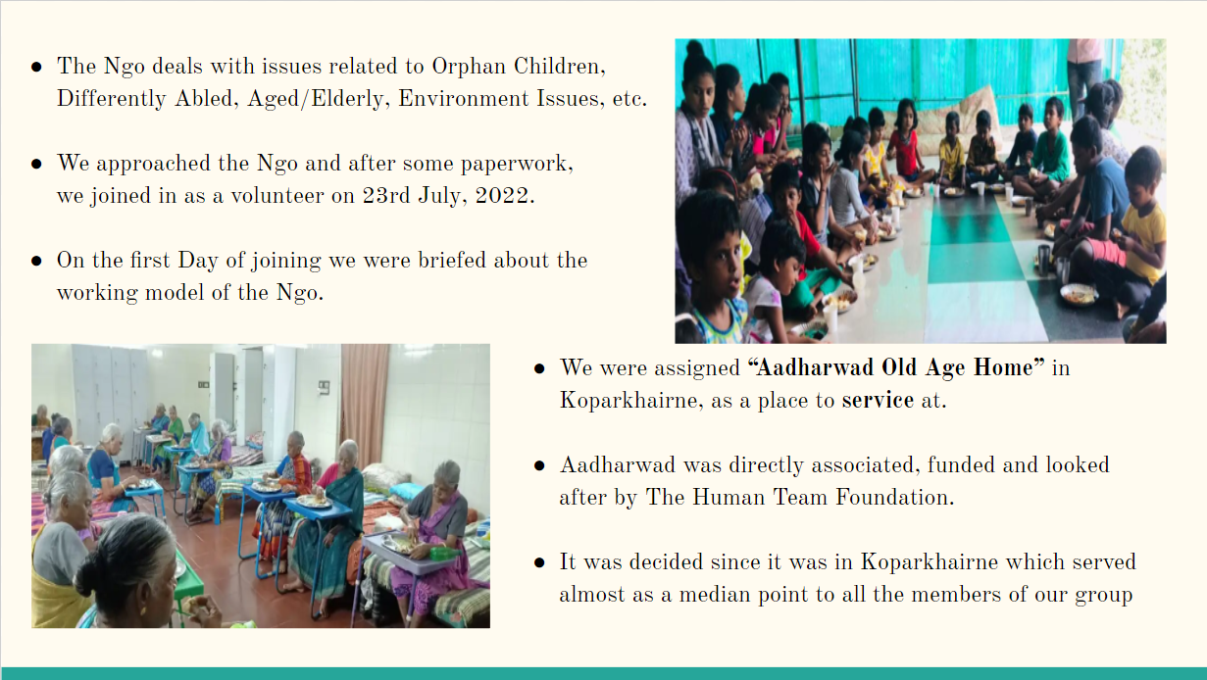

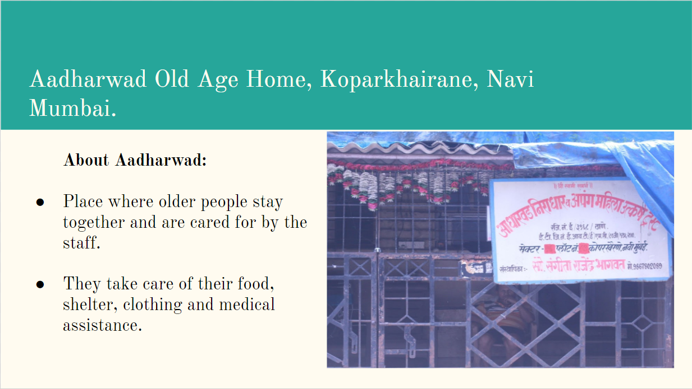

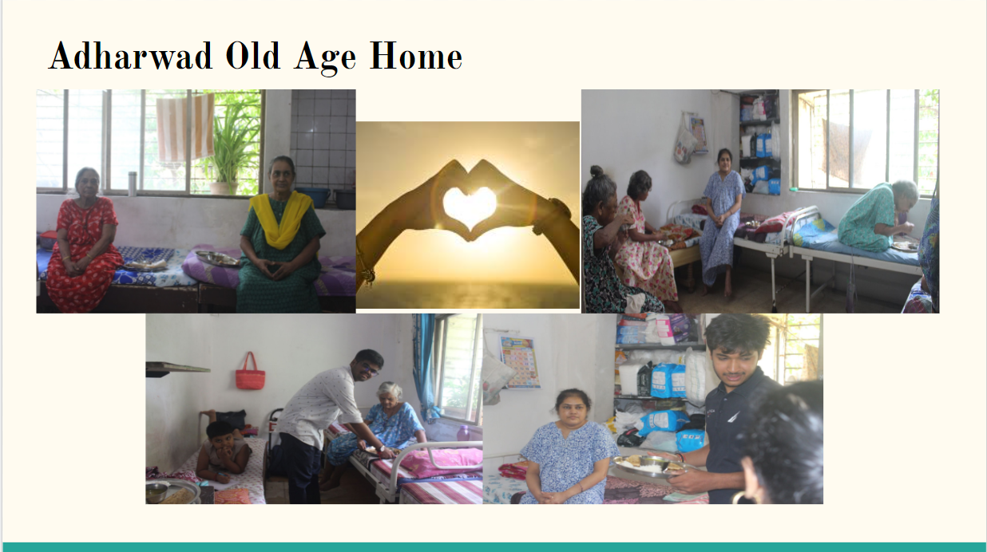

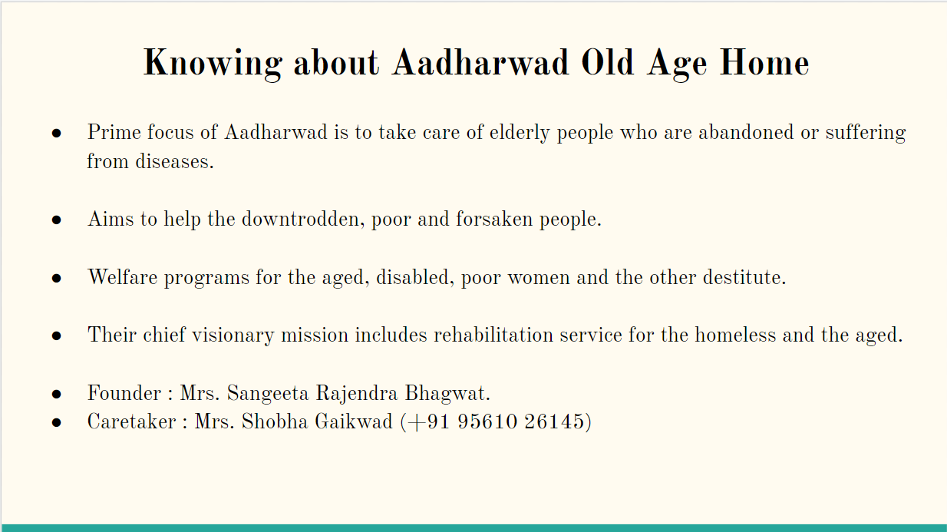

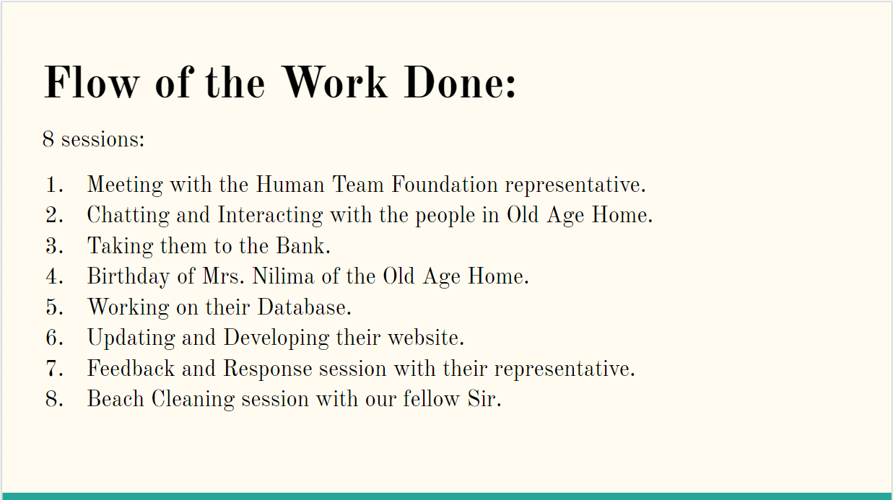

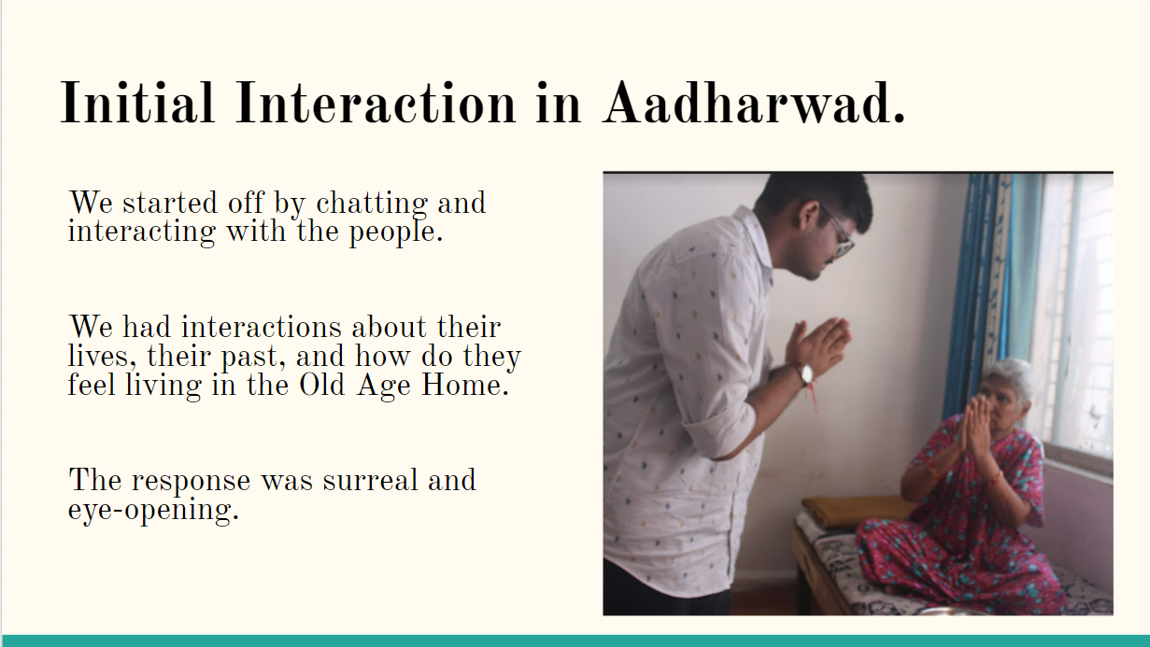

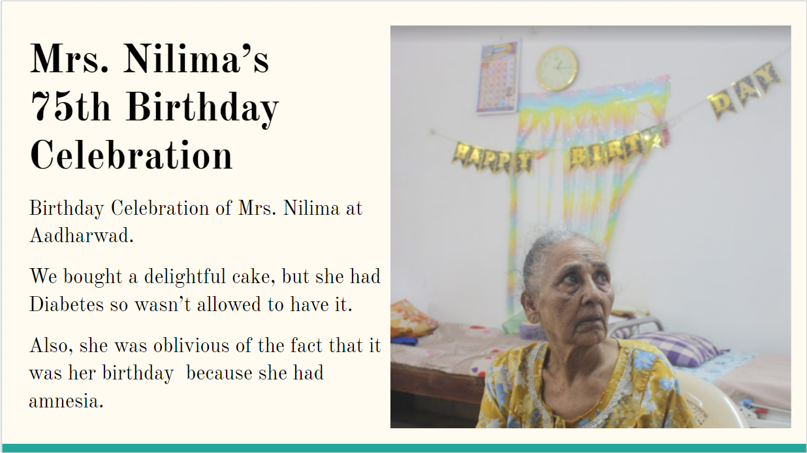

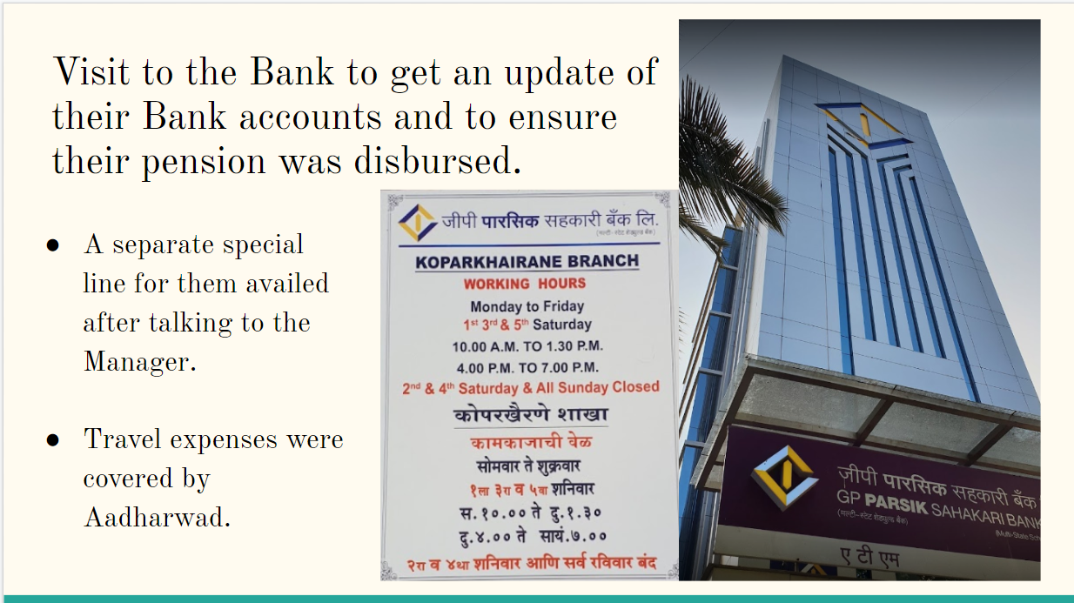

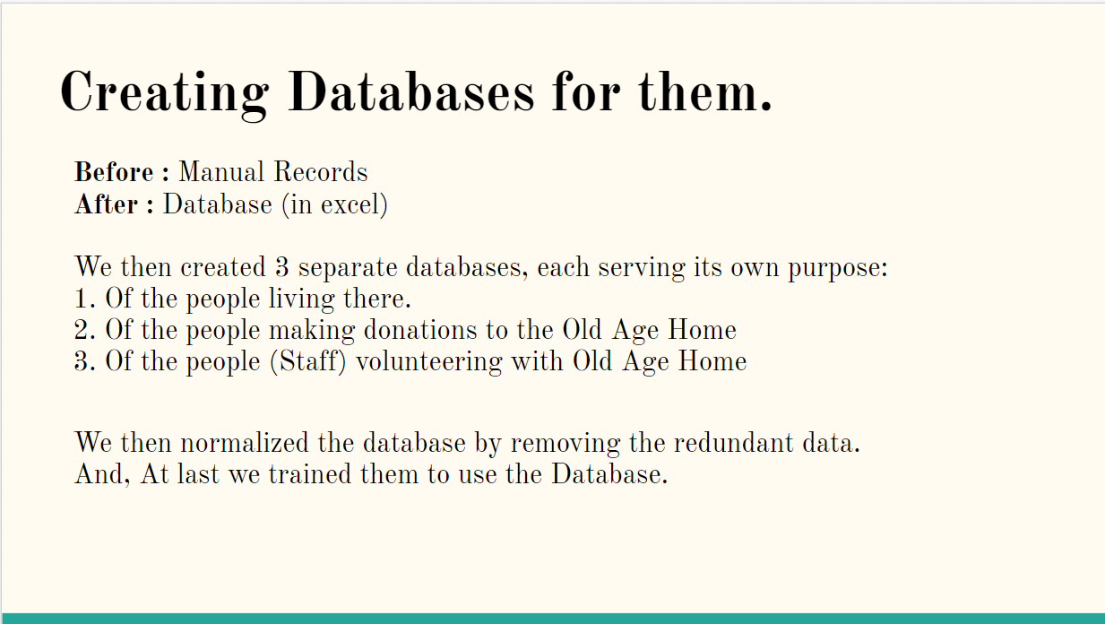

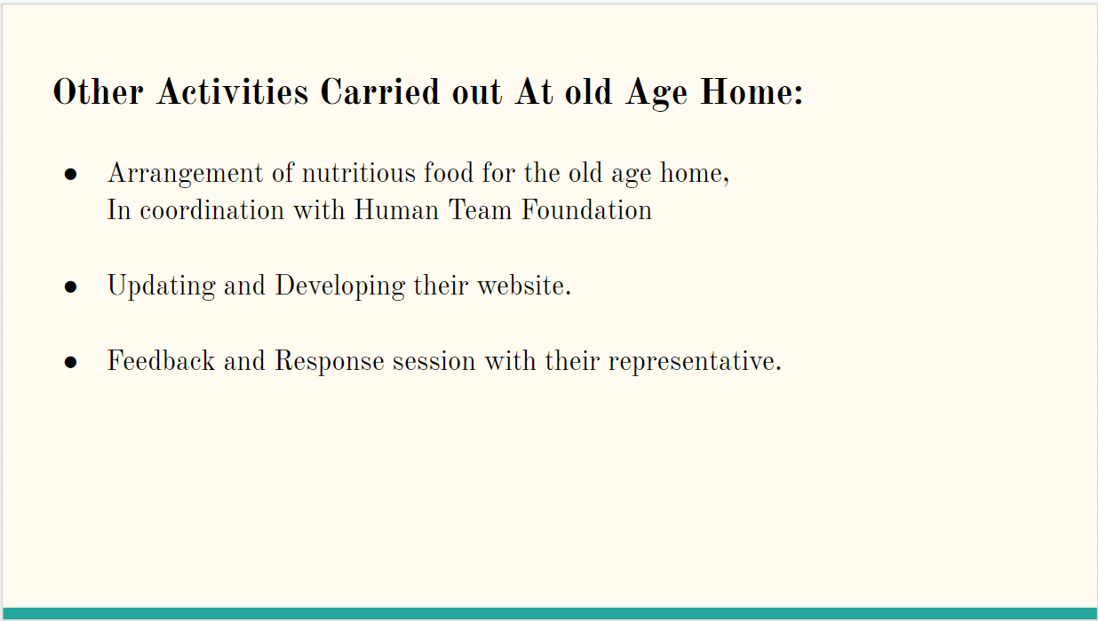

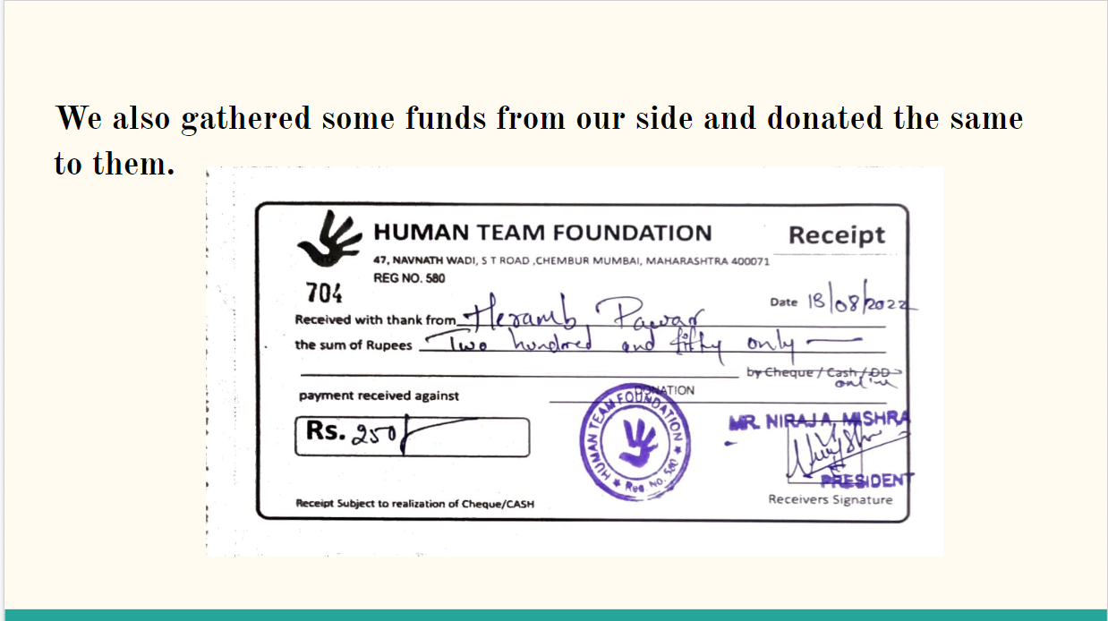

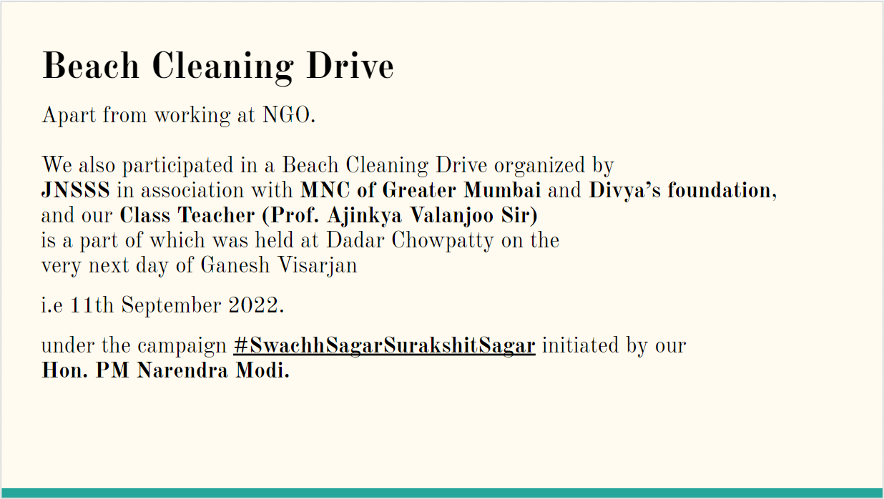

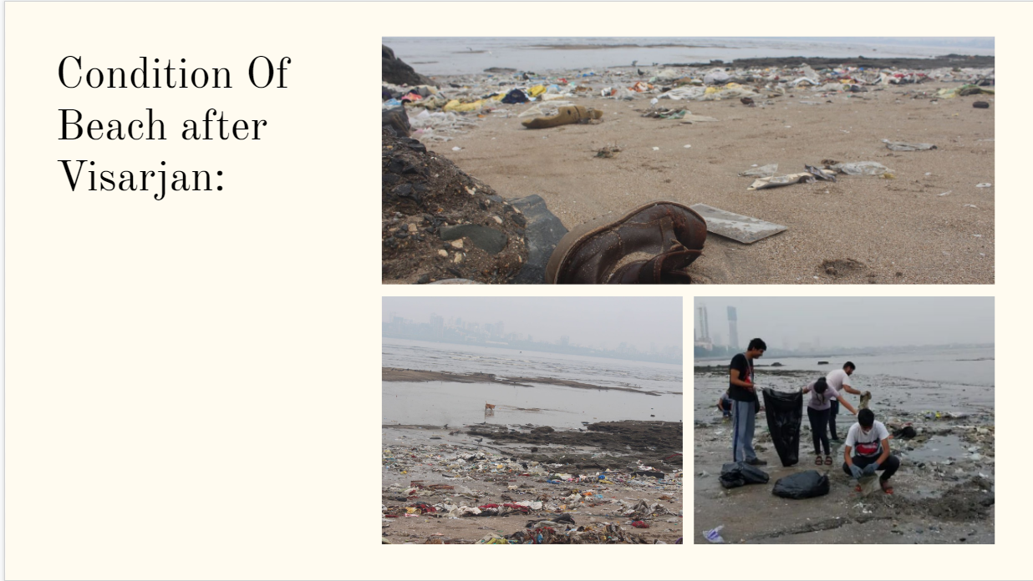

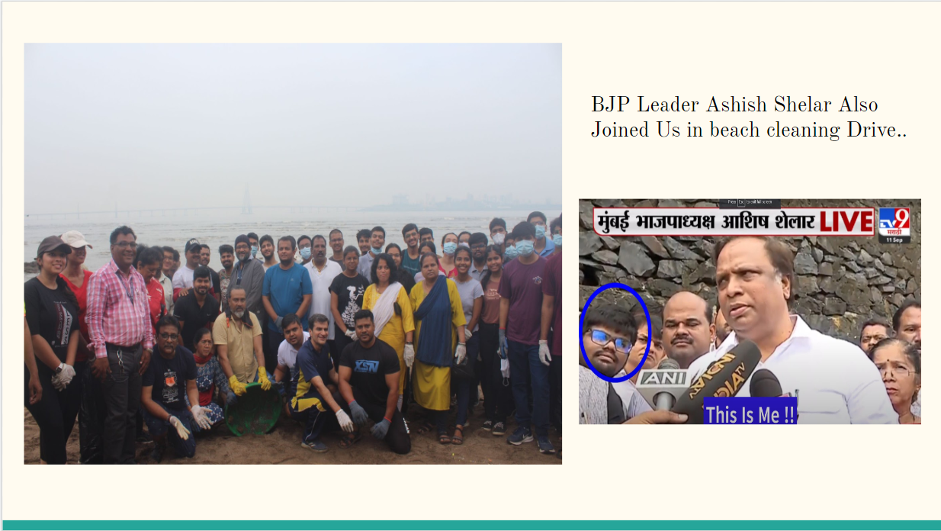

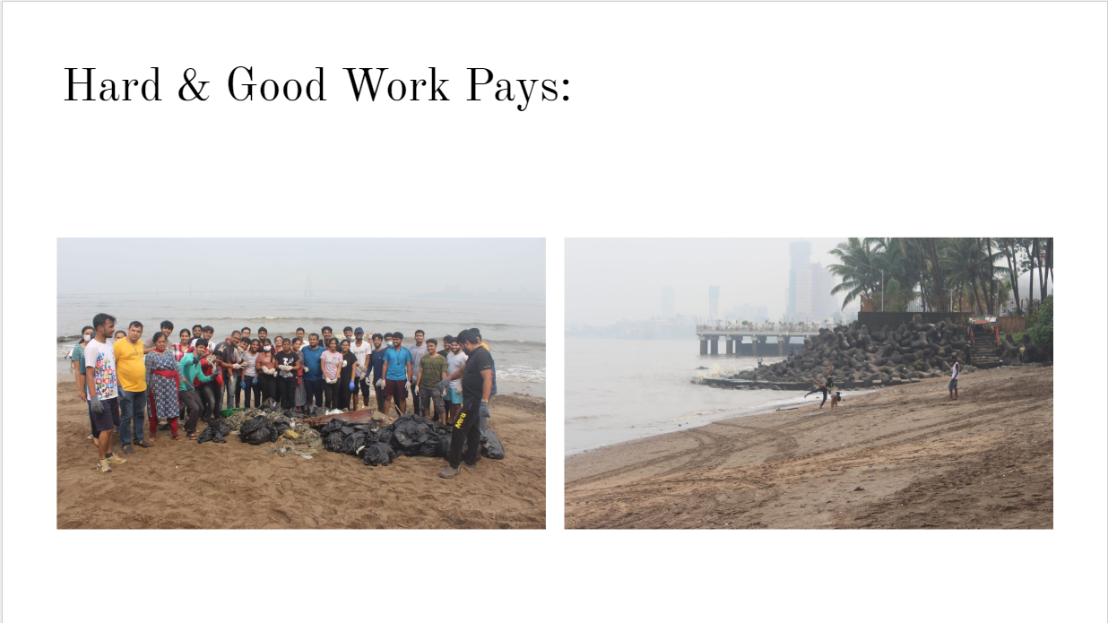

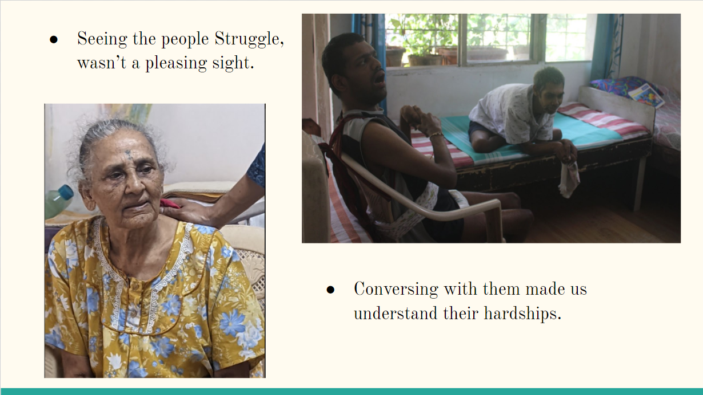

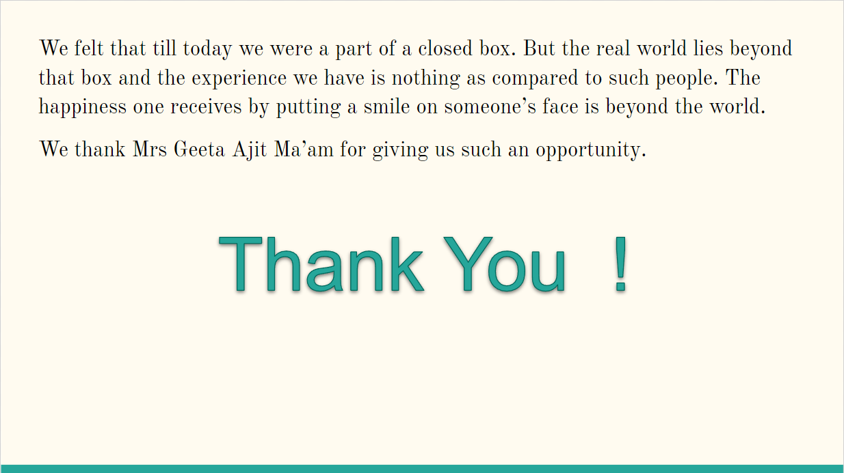

**Project Proposal**

A Technical Proposal for

**Volunteering at Human team foundation - Group 07**

By

| **Name** | **Roll No.** |
| --- | --- |
| Arunim Chakraboty | 7 |
| Shubham Hadawle | 17 |
| Janhavi Khanvilkar | 27 |
| Manav Pahilwani | 37 |
| Yash Sarang | 47 |
| Avinash Srivastava | 57 |
| Heramb Pawar | 67 |

Submitted To

**Dr. Geeta Ajit** on **23rd August 2022**

Assistant Professor

Department of Humanities and Applied Sciences

**Volunteering for Human Team Foundation Proposal writing**

**Introduction:**

**About Human Team Foundation**:

Human Team foundation provides help to anyone those are in need, like the orphans, elderly people, stray animals. They help the needy ones and show the care and love to all the living beings irrespective of their caste, sex and creed.

It shares as much happiness as possible, specially to challenged children or the children who are struggling alone in this world.

Not only this, they provided help even during pandemic, such as providing food packets and medicines to the needy.

**Purpose:**

The main aim of this endeavor is to provide help by volunteering at NGOS. We hope to help the Foundation by providing support to the needy children and elders. Human team foundation oversees numerous NGOs in and around Mumbai which work to solve various social issues like helping elderly, the orphans, and the needy. We hope to provide any help we can, be it of social or technical nature.

**Overview**:

We wanted to contribute towards the betterment of society in some or the other way so we got in touch with the Human Team Foundation NGO.The NGO directed us to Adharwad Old Age Home in Kopar Khairane. The old age home consisted of almost 30-40 elderly people living under one roof. The old age home takes care of them by providing healthy and nutritious food, organizing timely health check-ups. We got the chance to serve these elderly people for some days. We hope that our efforts have helped the elderly people and the old age home in some or the other way.

**Location:**

* **Human Team Foundation:** Chembur, Mumbai.
* **Adharwad Old Age Home:** Kopar Khairane, Navi Mumbai.

**Key responsibilities:**

1. Support them in an adequate manner and help them by providing the things required.
2. Recognize their perspectives and make every effort to assist them.
3. To bring them out of the alone world and make them a better individual.
4. Offer our support in helping the elderly people.
5. Assisting the staff at the old age home.
6. Helping them maintain a proper Database and website

**Time duration:**

30 hours (Includes meeting with Human Team Foundation Representative for 2 hours)

**Time Commitment**:

Assignment to be completed in 15 days (starting from the date of first meeting)

**Skills and Experience Required:**

1. Good technical skills
2. Caring Attitude
3. Understanding and calm behavior

**Summary:**

The group aims to help serve the elderly people at the old age home in some way. It also aims to develop and maintain a proper database and maintain a website for the old age home using our technical skills. During this period, we aim to that our presence bring some betterment at old age home and helps to establish a certain relation between us

**Methodology**:

When approaching the Human Team Foundation, we as a group had decided that we would like to work in a domain where we would be able to help the elderly people. Keeping this in mind, we were introduced to Adharwad Old Age Home, an Old Age consisting of almost 30-40 elderly people living under one roof. After discussion, we were allocated to work with the staff at the old age home

Our work consisted of helping the old age home with their database and helping the old age home staff to take the old people to the bank.

We also helped some of the old people in filling, solving their long pending issues in the bank due to unnecessary reasons, and standing in Queues on their behalf.

**\*\*\*\*\***